# Multi-Paradigm Report

## Introduction to Programming Paradigms

Programming paradigms are a way to classify programming languages based on their features. Some languages are developed to support a single paradigm (Smalltalk and Haskell), whilst others are designed to support multiple paradigms (Ruby, Python and Java).

The two main approaches to programming are imperative programming and declarative programming.

Imperative programming is based on Von Neumann architecture and is one of the oldest paradigms. It explicitly tells the computer what to do and how to do it – a sequential set of instructions. Whereas declarative programming focuses on what needs to be achieved instead of instructions on how to achieve it.

The three main paradigms in the imperative programming approach are Procedural Programming Paradigm, Object Oriented Programming Paradigm and Parallel Processing Paradigm. The three paradigms in the declarative programming approach are Logic Programming Paradigm, Functional Programming Paradigm and Database Processing Paradigm.

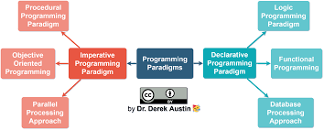

The assignment focuses on using two programming languages – C and Java. C is a procedural programming language and Java is an object-oriented programming language.

<https://theailearner.com/2018/09/26/programming-paradigms/>

WRITE A PARAGRAPH ON C and ON JAVA.

<https://www.guru99.com/c-programming-language.html>

<https://en.wikipedia.org/wiki/Java_(programming_language)>

## Difference between C and Java

<https://www.geeksforgeeks.org/difference-between-java-and-c-language/>

## Procedural Programming Paradigm

## Object Oriented Programming (OOP)

## References

<https://www.geeksforgeeks.org/introduction-of-programming-paradigms/>

<https://en.wikipedia.org/wiki/Programming_paradigm>

Include here information on C and Java – features, developed by, what year

, what type ie object orientated